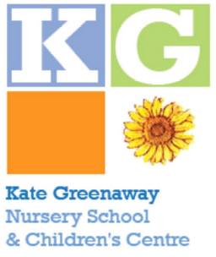

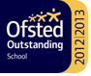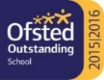

15th March 2022

Dear Parent/Carer ,

PARENT GOVERNOR VACANCY

We have a vacancy for 1 parent governor, which we need to fill as soon as possible.

Kate Greenaway Nursery School has always aimed for a partnership with parents, which undoubtedly brings great benefits to the children. One of the most significant ways you can help in promoting this aim is to volunteer to be a parent governor. The governing board’s main tasks are to ensure that pupils receive high quality education, to plan for future development and improvement, and to support the school. Whilst specialist knowledge or relevant experience is useful, common sense and willingness to give time are key requisites. We have a fact sheet about becoming a governor we can send you, if you would like further information.

Parent governors are welcomed as valued members of the team and play a vital role in ensuring the governing board is aware of the views of parents and the local community. We feel sure that there are parents prepared to take on this important role and give their time and commitment to helping us to continue to improve the school’s performance. We very much hope that parents from all the many communities in the school would be interested in standing. Anyone who has parental responsibility for a pupil on the school roll at the time of the election can stand for election*; may nominate someone for election; and may vote in the election. Roughly speaking, parental responsibility means someone with whom the child is living, but if you are not sure about this, please contact the school office who will be able to explain in more detail.

The school office should receive all nominations by 3.00pm on 28th March 2022. You do not need a seconder, and you can nominate yourself. Every nomination, however, must be signed by the candidate stating that s/he is willing to stand. Candidates are also asked to write a few words (50-100) about themselves and why they wish to become a governor. Candidates are unable to withdraw from the election once ballot papers have been circulated.

Ballot papers and election statements will then be sent home by post/pupil post on 1st April 2022. The closing date for the return of ballot papers is 8th April at 3.00pm. The ballot is secret; you may send or post the ballot paper back in a sealed envelope addressed to the returning officer, or drop it into the secure ballot box in the school office by the deadline. Ballots will be counted at 4.00pm on 19th April and all candidates are invited to attend.

The returning officer for this election is Diana Valcheva.

If you would like to know a little more about becoming a parent governor, you are welcome to speak to me.

Yours sincerely

Diana Valcheva – Headteacher

* Parents who work at the school for 500 hours per year or are elected members of Islington Council, are not eligible to be parent governors, but are eligible to vote in parent governor elections.

